***UNEARTHING THE IMPACT OF HUMAN ACTIVITY***

***INTRODUCTION***

Humans impact the physical environment in many ways: overpopulation, pollution, burning fossil fuels, and deforestation. Changes like these have triggered climate change, soil erosion, poor air quality, and undrinkable water. These negative impacts can affect human behavior and can prompt mass migrations or battles over clean water.

**PROBLEM DEFINITION & DESIGN THINKING**

**Empathy Map**

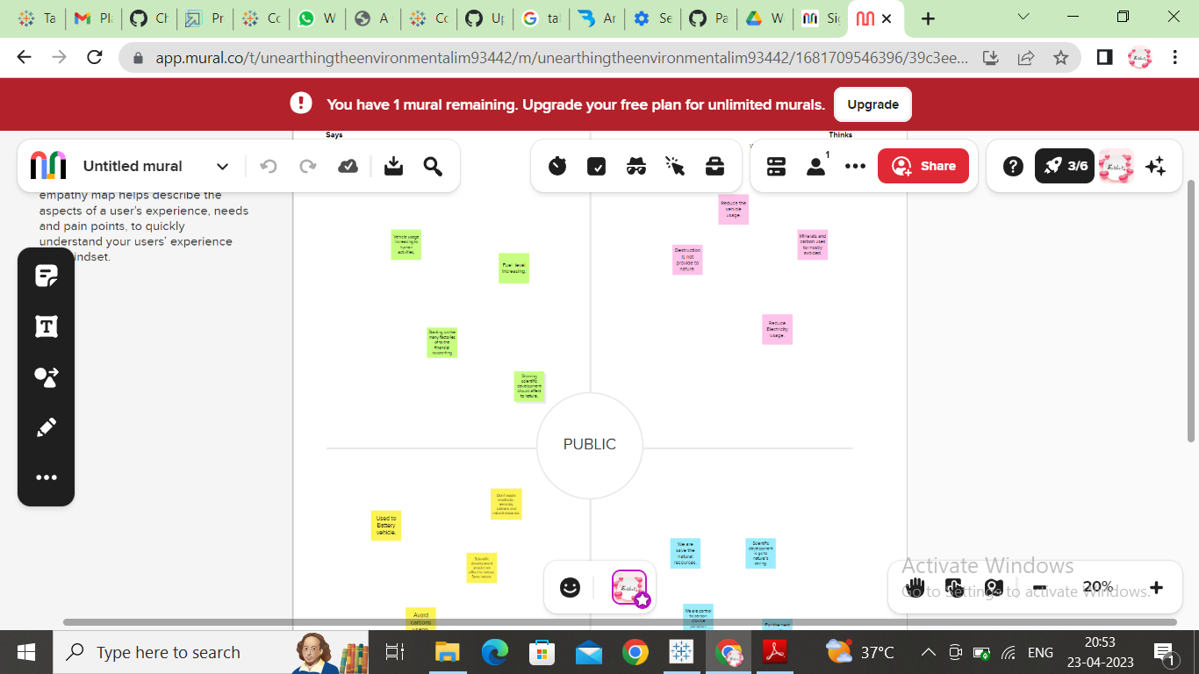

***Ideation & Brainstorming Map***



***TABLEAU DESKTOP***

***Worksheet***

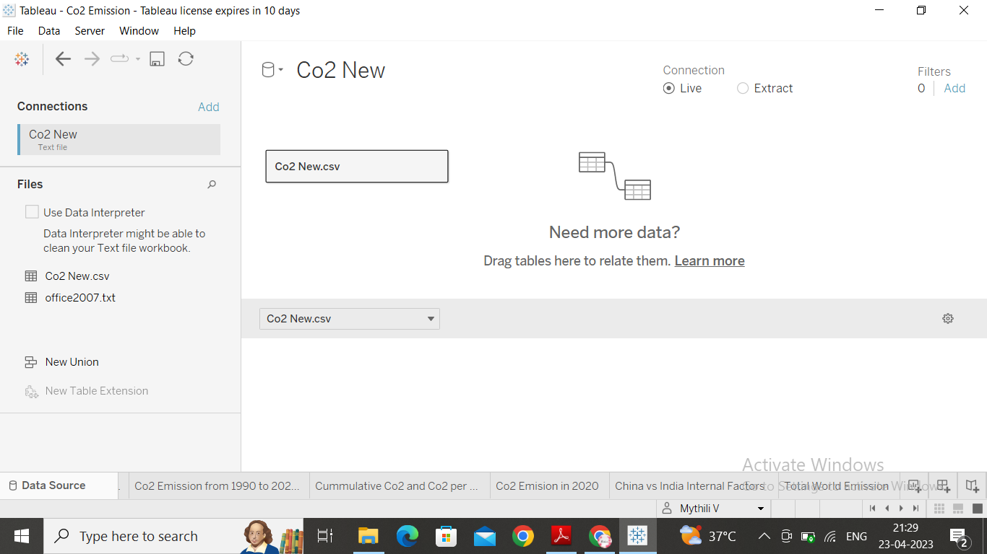

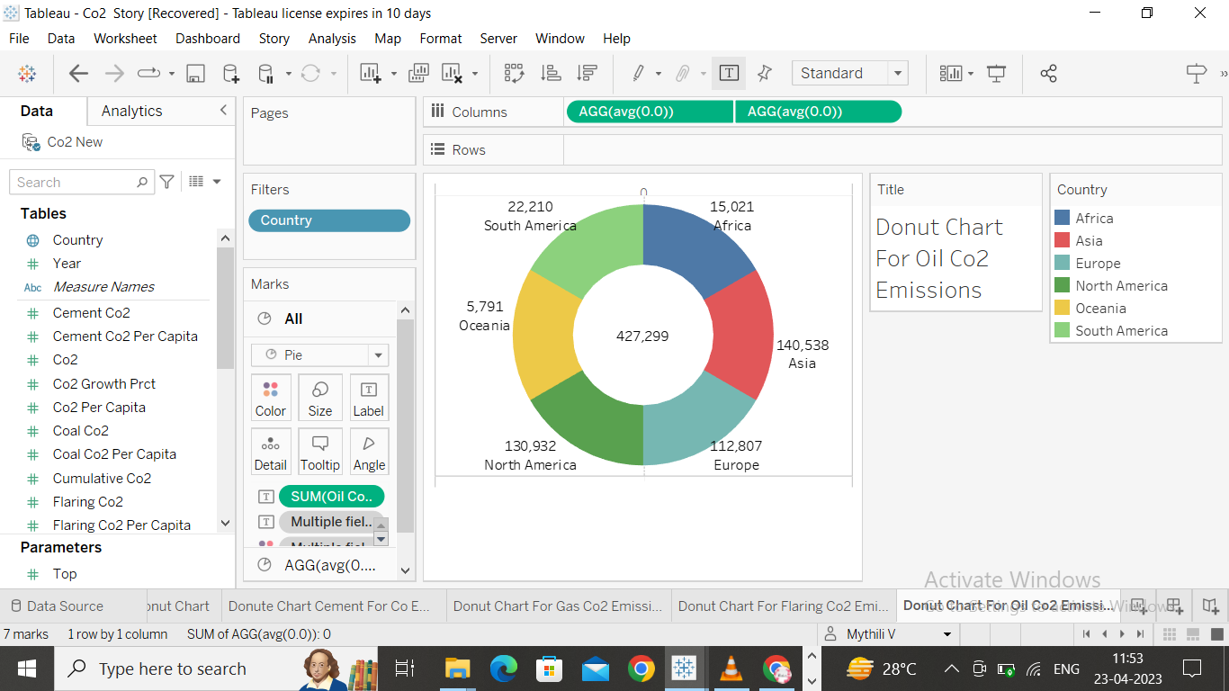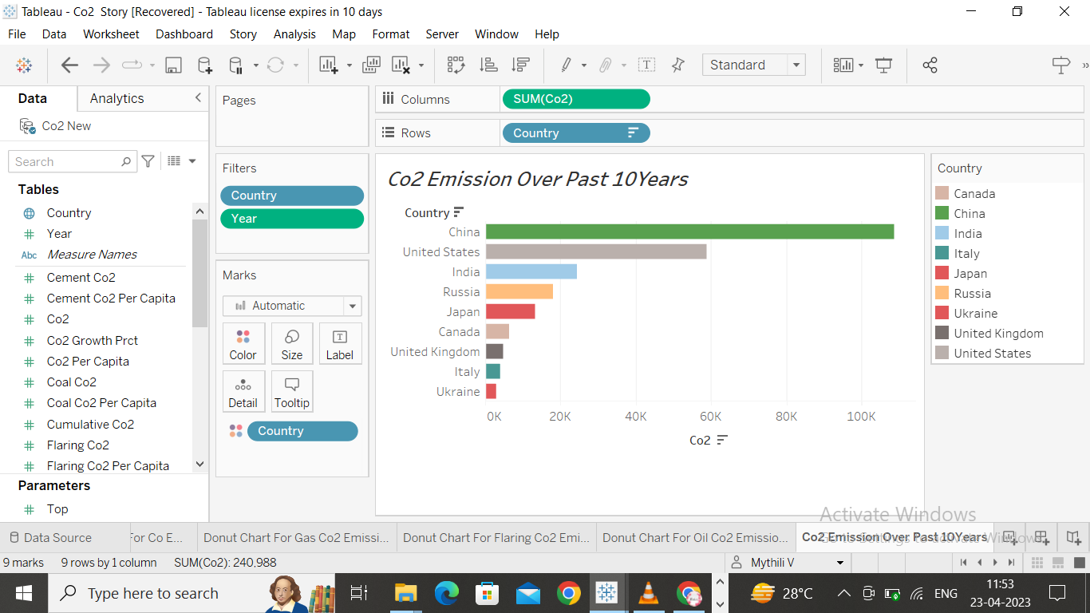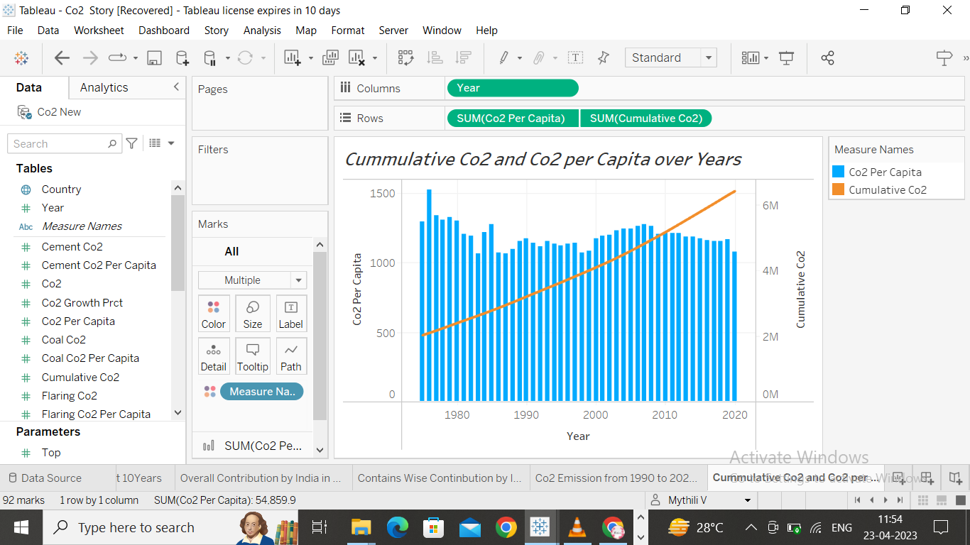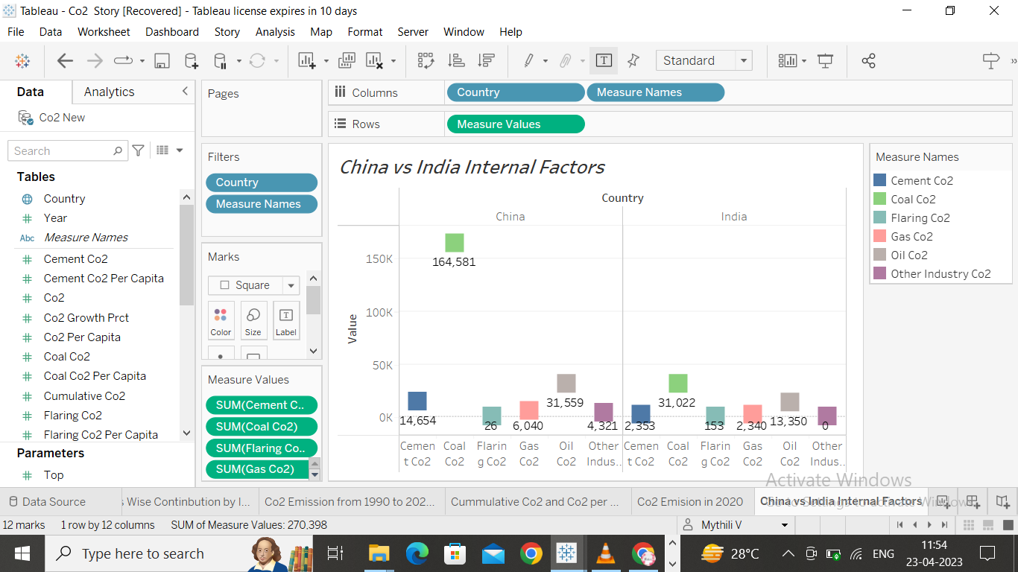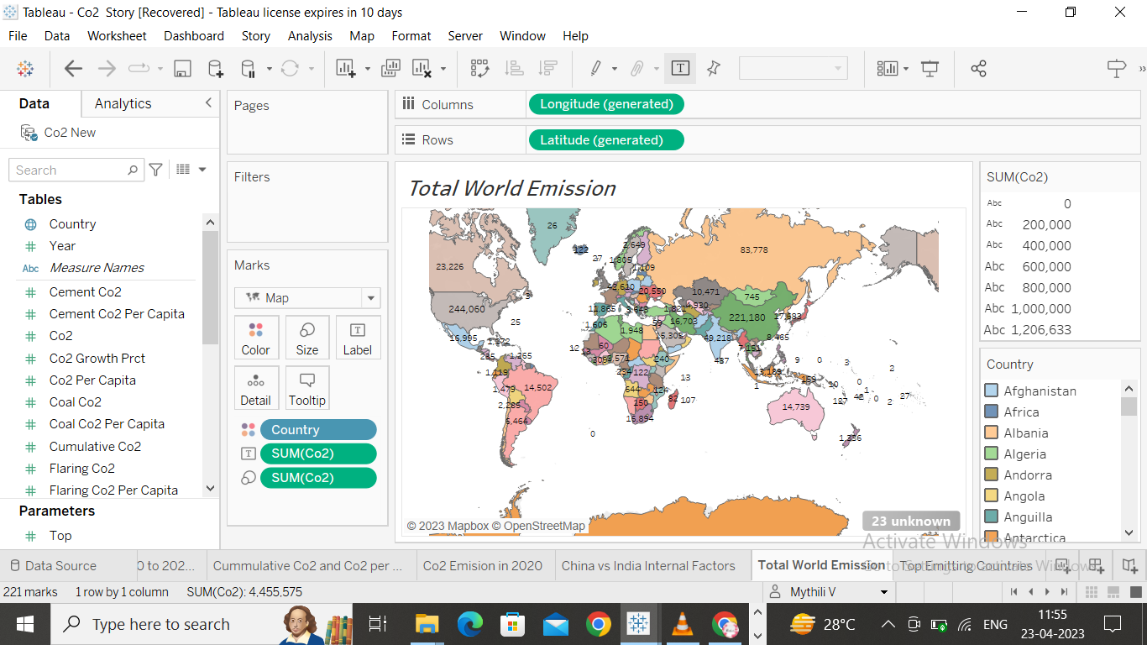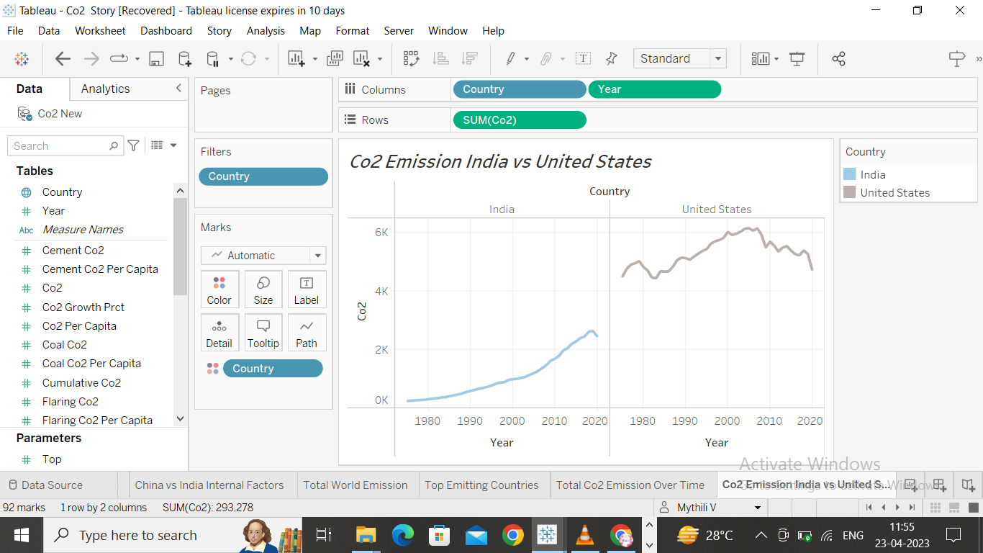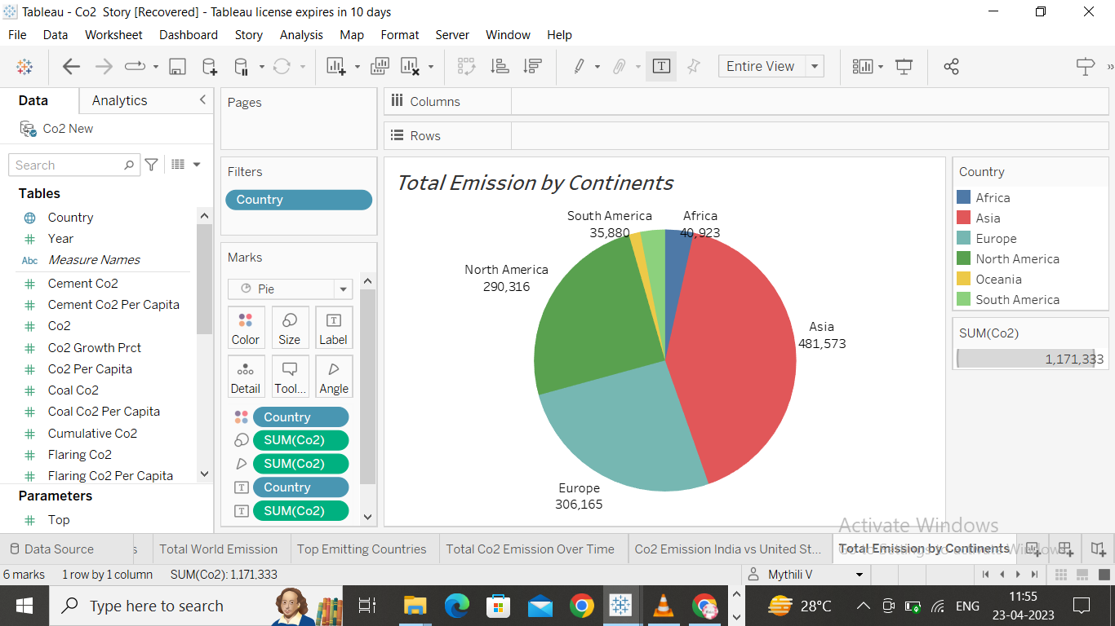

***Dashboard***

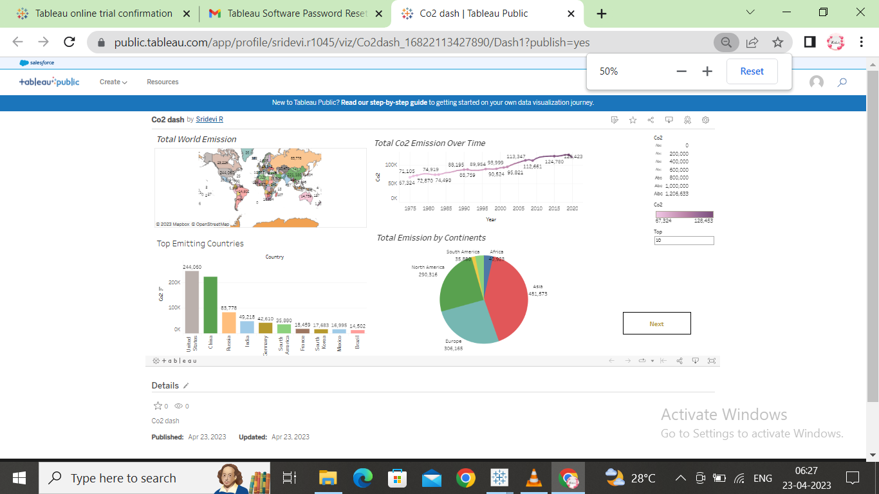

***Story***

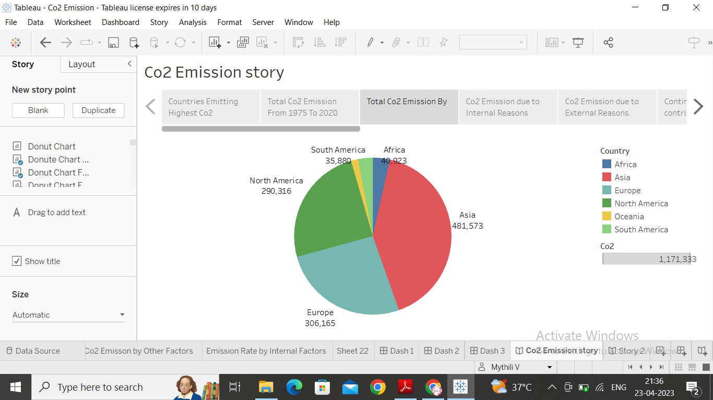

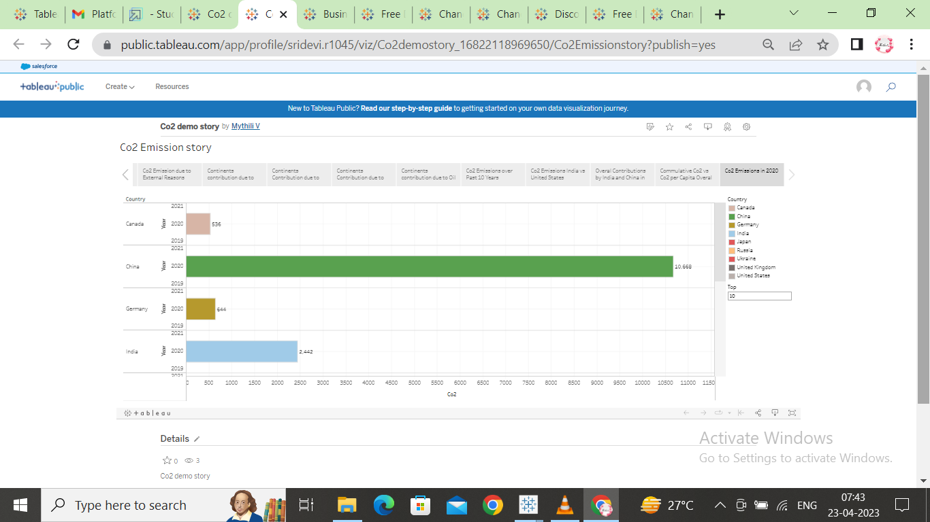

*ADVANTAGE*

Green plants grow faster with more CO2. Many also become more drought- resistant because higher CO2 levels allow plants to use water more efficiently. More abundant vegetation from increased CO2 is already apparent.

DISADVANTAGE

Carbon dioxide gas can be toxic and very harmful to humans, It increases the temperature of the Earth's atmosphere, It causes the global warming effect that has bad effects on the Earth.

RESULT

Global carbon dioxide (CO2) emissions from energy combustion and industrial processes1 grew 0.9% or 321 Mt in 2022 to a new all-time high of 36.8 Gt

FUTURE SCOPE

Global co2 emissions forecast

CO2 emissions from energy combustion grew by around 1.3% or 423 Mt in 2022, while CO2 emissions from industrial processes declined by 102 Mt. Emissions growth in 2022 was below global GDP growth (+3.2%), reverting to a decades-long trend of decoupling emissions and economic growth that was broken in 2021.

APPENDIX

